

**My Zoo Shop**

Database Model

EPAM learning

A short description about my concept:

The Zoo Shop database is designed to handle the complete operations of a retail store specializing in pet supplies, live animals, and related services. Customers can browse, purchase, and order products both in-store and online. The database also supports various services like grooming appointments and consultation bookings. By integrating customer, employee, and supplier information, the system ensures smooth inventory management, seamless order processing, and effective customer engagement.

About entities and data storage:

**1. Product**

* **Purpose**: Stores information about items available in the shop, such as food, toys, accessories, and live animals.
* **Attributes**:
  + **Product ID (Primary Key)**: A unique identifier for each product.
  + **Name**: The name of the product (e.g., "Dog Leash", "Parrot Food").
  + **Category**: The category the product belongs to (e.g., Food, Accessories, Animals).
  + **Price**: The cost of the product per unit.
  + **Quantity in Stock**: The number of items available in the inventory.
  + **Description**: Additional details about the product.
  + **Supplier ID (Foreign Key)**: Links to the supplier providing the product.

**2. Order**

* **Purpose**: Captures information about customer purchases, whether made in-store or online.
* **Attributes**:
  + **Order ID (Primary Key)**: A unique identifier for each order.
  + **Date and Time**: The timestamp for when the order was placed.
  + **Customer ID (Foreign Key)**: Links to the customer who placed the order.
  + **Total Amount**: The total price of the order.
  + **Order Status**: Tracks the progress of the order (e.g., Pending, Completed, Cancelled).
  + **Discount Applied**: Any discounts applied to the order.

**3. Order Item**

* **Purpose**: Represents individual products included in an order, resolving the many-to-many relationship between Orders and Products.
* **Attributes**:
  + **Order Item ID (Primary Key)**: A unique identifier for each order line.
  + **Order ID (Foreign Key)**: Links to the associated order.
  + **Product ID (Foreign Key)**: Links to the product included in the order.
  + **Quantity**: Number of units of the product ordered.
  + **Subtotal**: The total price for the ordered quantity of the product.

**4. Customer**

* **Purpose**: Maintains information about individuals who shop at the zoo store.
* **Attributes**:
  + **Customer ID (Primary Key)**: A unique identifier for each customer.
  + **Full Name**: The name of the customer.
  + **Phone Number**: Contact phone number.
  + **Email**: Email address.
  + **Address**: Delivery or residential address.
  + **Membership Status**: Indicates whether the customer has a membership and its level (e.g., Basic, Premium).

**5. Employee**

* **Purpose**: Tracks employee data and their roles in the store's operations.
* **Attributes**:
  + **Employee ID (Primary Key)**: A unique identifier for each employee.
  + **Name**: The employee's full name.
  + **Position**: The employee's job role (e.g., Sales, Delivery, Manager).
  + **Phone Number**: Contact phone number.
  + **Email**: Email address.

**6. Supplier**

* **Purpose**: Records information about external suppliers who provide products to the store.
* **Attributes**:
  + **Supplier ID (Primary Key)**: A unique identifier for each supplier.
  + **Name**: Name of the supplier.
  + **Contact Information**: Phone number and email for communication.
  + **Address**: Location of the supplier.

General info about the planned daily operations

**For Customers:**

* **Order Management**: Customers can place, view, and cancel orders.
* **Product Browsing**: Customers can search for products by category, price, or availability.
* **Membership Management**: Customers can sign up for or upgrade their membership.

**For Employees:**

* **Order Management**: Employees can update order statuses, process returns, and view completed orders.
* **Inventory Management**: Employees can update stock levels and check product availability.
* **Reporting**: Generate performance reports for sales, employees, and top-selling products.

**For Administrators:**

* **Employee Reports**: Analyze employee performance based on the number of orders processed.
* **Revenue Analysis**: Generate reports on revenue by product category, time period, or employee.
* **Customer Insights**: Identify top customers for targeted promotions and special offers.

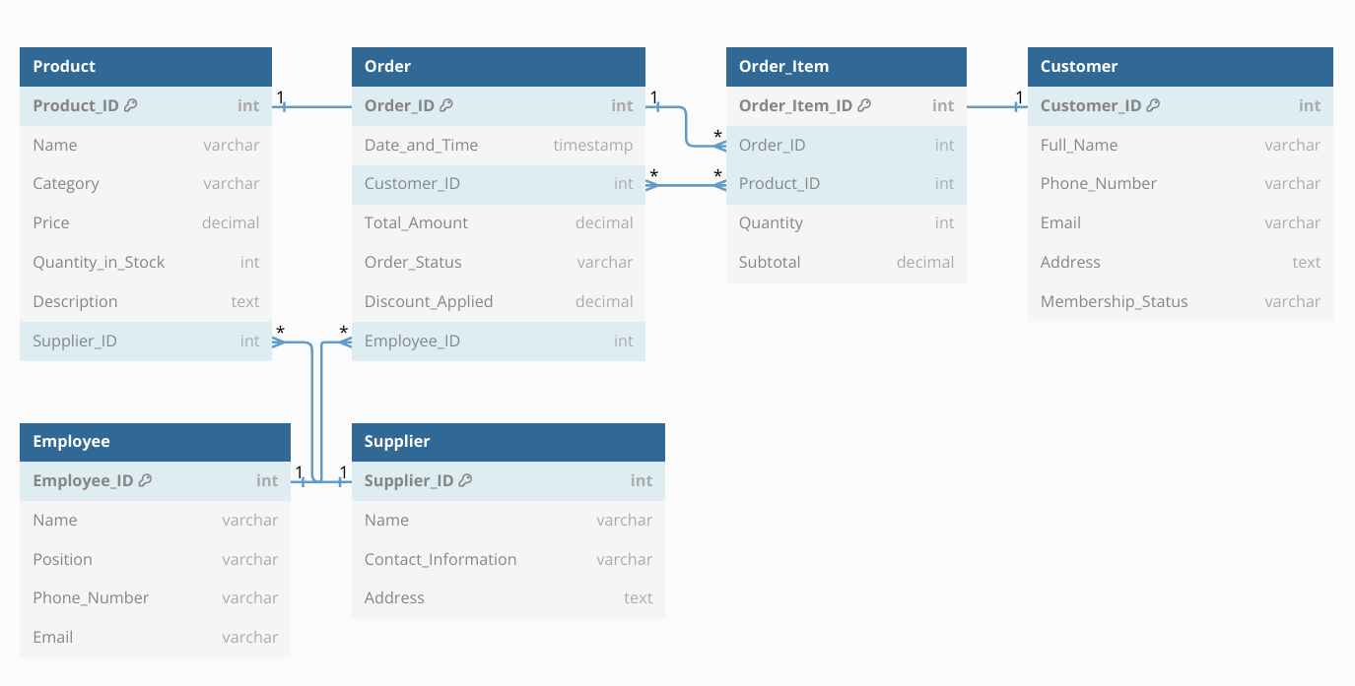

**Relationships:**

1. **Product and Supplier (1:N):**
   * **Each supplier provides multiple products, but each product is supplied by one supplier.**
2. **Order and Customer (1:N):**
   * **A customer can place multiple orders, but each order is associated with only one customer.**
3. **Order and Employee (1:N):**
   * **Each order is processed by one employee, but an employee can process multiple orders.**
4. **Order and Order Item (1:N):**
   * **Each order can contain multiple order items, but each order item belongs to one order.**
5. **Product and Order Item (1:N):**
   * **A product can appear in multiple order items, but each order item corresponds to one product.**

**Justifications for Relationships**

* **One-to-Many Relationships**:
  + A customer can place multiple orders, but an order belongs to one customer.
  + A supplier can provide multiple products, but a product comes from one supplier.
* **Many-to-Many Relationships** (resolved through Order Item):
  + Products and Orders have a many-to-many relationship, as a product can appear in multiple orders, and each order can contain multiple products.

**Normalization**

The database is normalized to the third normal form (3NF):

1. **Atomic Attributes**: All attributes store indivisible values.
2. **No Partial Dependencies**: All non-key attributes depend on the entire primary key.
3. **No Transitive Dependencies**: There are no indirect dependencies between non-key attributes.